05-01-2012

**(a) Further investigations on the ODT:**

We try to locate the origin of the double beam of the CODT. To this end we first used the atoms to visualize the the beam shape, i.e. we pulsed on the CODT during time-of-flight of atoms released from the magnetic trap. We clearly see the double beam shape (only the CODT is on!):

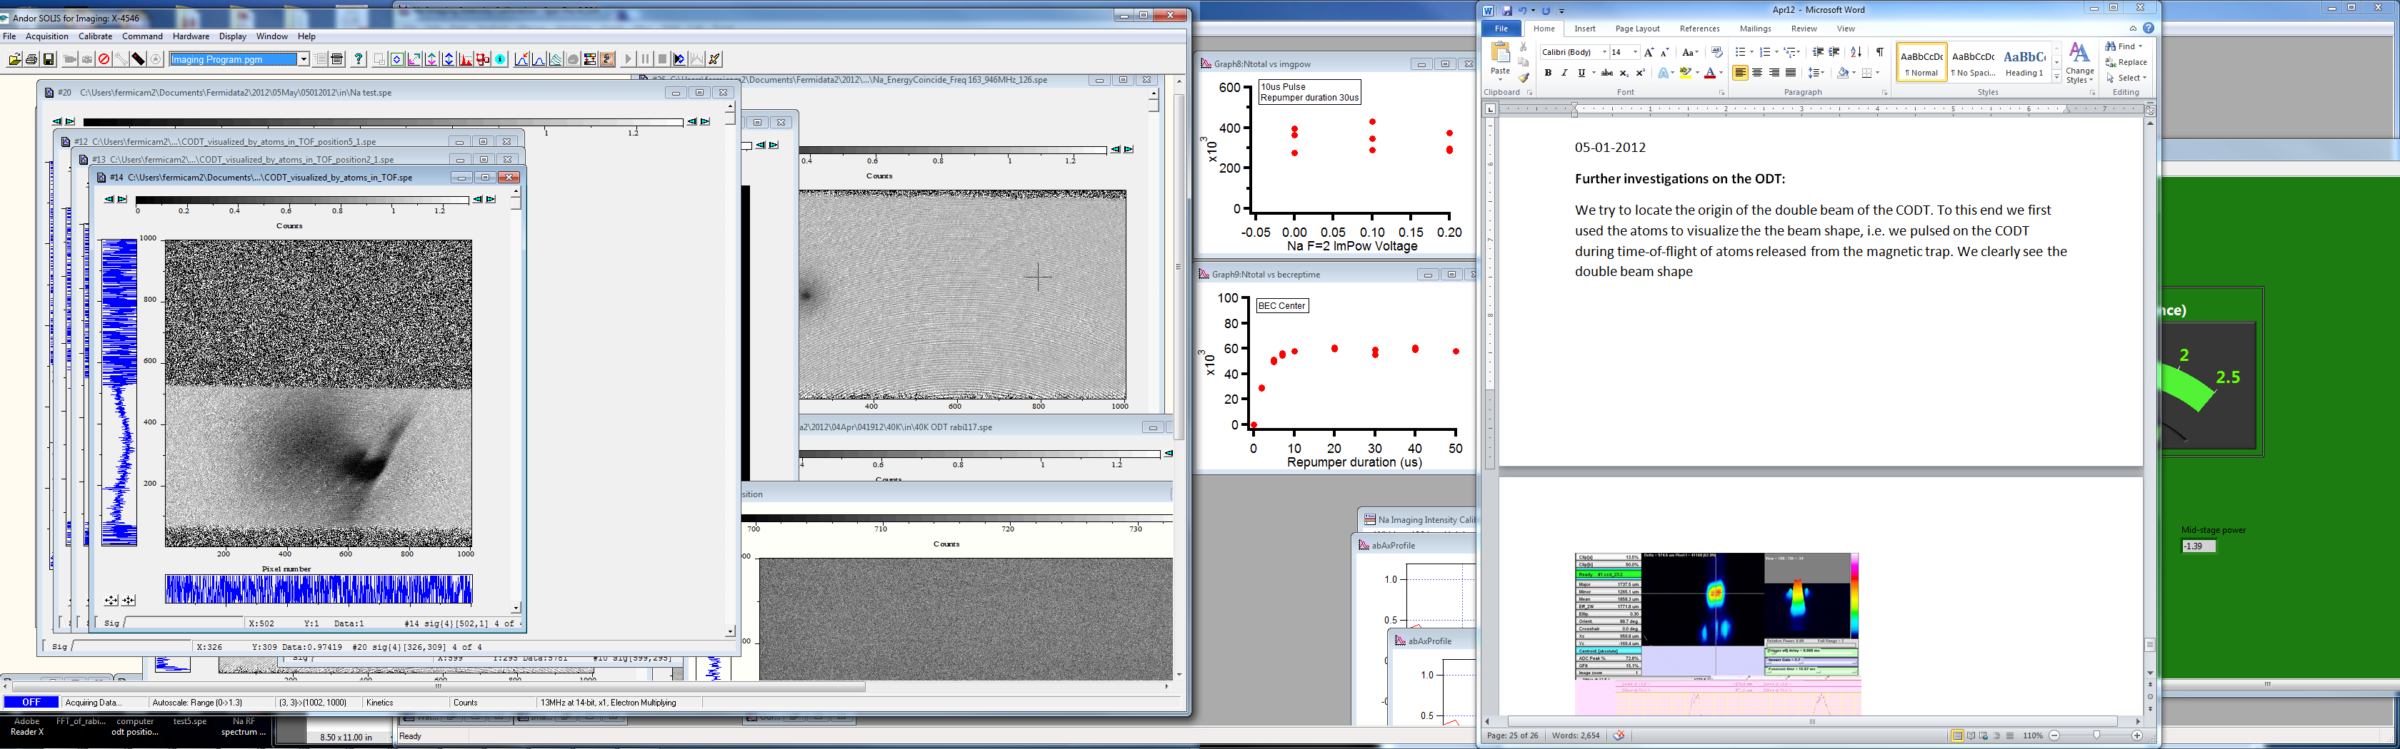

When moving the beam around the structure does not change considerably.

(Note: Using this time-of-flight visualization, we actually also see a double beam structure on the PODT. However, the separation between the two beams is much larger, on the order of 100 pixels.)

So, the “weirdness” is robust. We used the WINcam beam profiler to locate the origin… to my surprise, the beam was already damaged before reaching the dichroic :D

In fact, the AOM is damaging the beam:

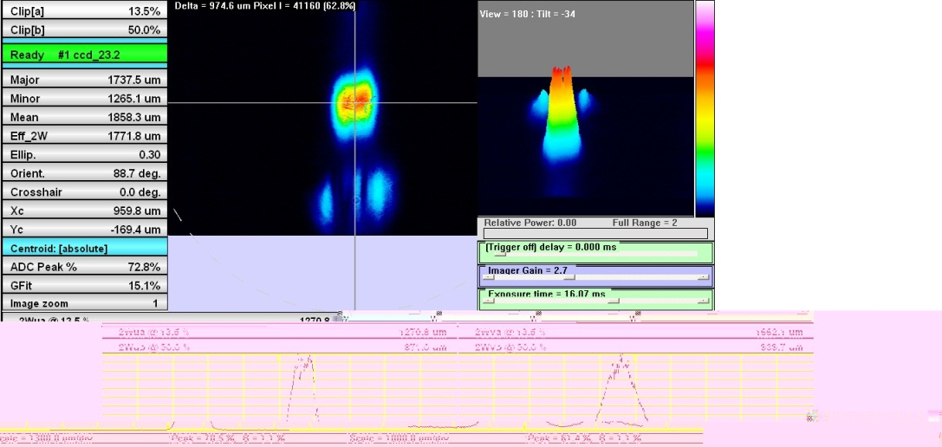

First order diffraction

Residual zeroth order…

The first order beam clearly shows the double structure.

It is probably very hard to aviod problems like this, when passing a beam through an AOM, in particular, if the wavefronts of the beam are not perfectly flat. (Note: Since the beam is high power, we cannot focus the beam on the AOM)

**So, we have one more reason, why it would be advantageous to send the dipole beam through a fiber:**

1. **Pointing instability** of the dipole trap beam due to frequency instability of the VCO driving the RF of the AOM…
2. **Mode cleanup:** Any imperfection of the beam shape before entering the entering the fiber will be gone. (Note: Even the beam after the fiber amplifier does not look perfect… it actually has a lot of light sprinkles. Multi-mode fiber!)

As a pragmatic work-around we align the AOM in a way, that the first order pretty much appears as a single beam! We may loose a little bit of power by this, but this is here only of secondary importance.

On the Wincam the beam looks like this:

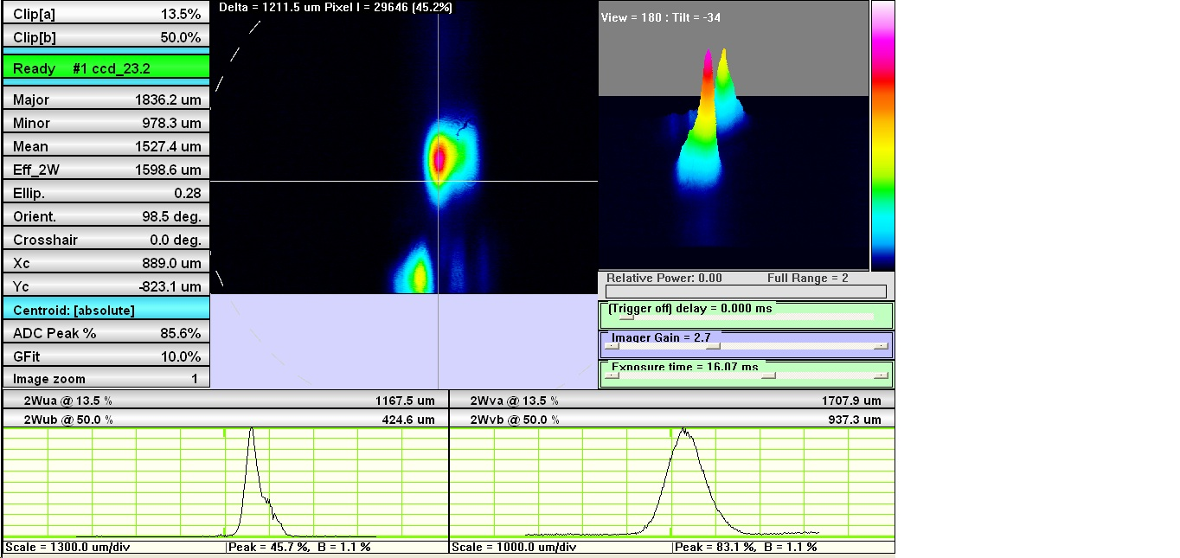

**Alignement of the dipole trap:**

Before starting alignment we figure out, which position of the crossed ODT can be expected to yield the best loading result. We decide to place the ODT underneath the lower pocket (viewed on zCam ) of the plugged trap. Viewed on yCam, we place the ODT 50 pixels (i.e. about 100 um) underneath the magnetic trap.

This yields the following ODT after tweaking… not perfect, but much better than before… (note: here the PODT is still switched off):

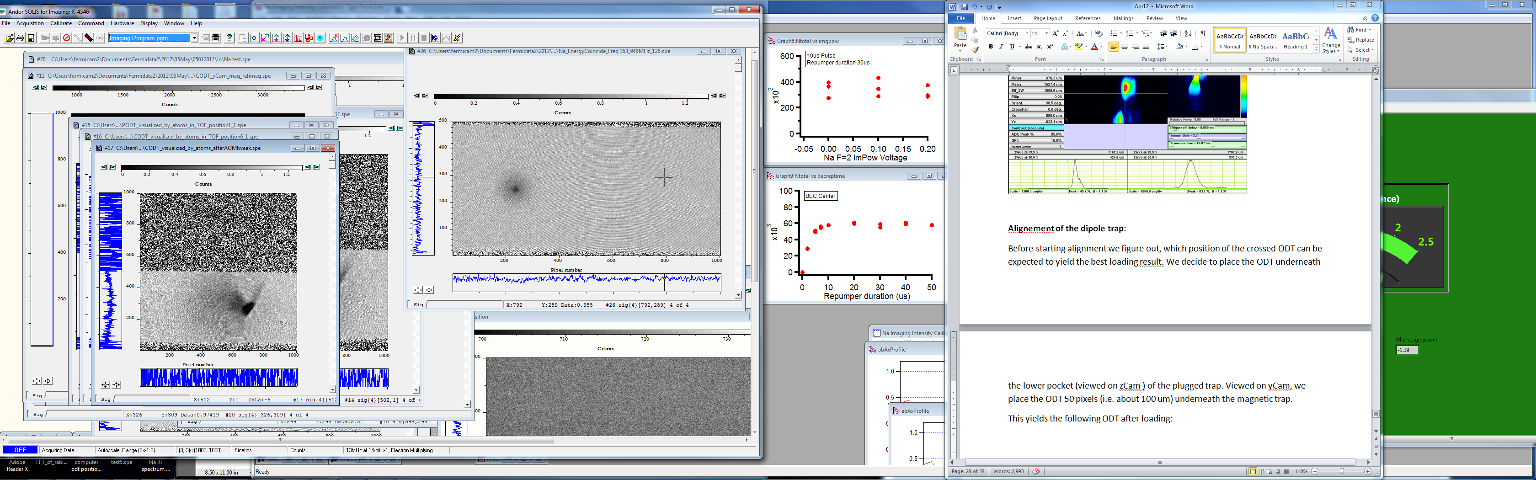

x dir.

x dir.

z dir.

zCam

yCam

When switching on the PODT beam in addition, we seem to get a fairly decent dipole trap. It is round in the horizontal plane for 1.0V / 0.15V (CODT / PODT)… i.e. the ratio of control voltages is about 6 to 7!

For these parameters we manage to get a huge condensate after only 1.5 to 2 sec evaporation (sodium in 2,2 state, here 15ms TOF) (Note: so we seemingly get larger BECs for round dipole traps!):

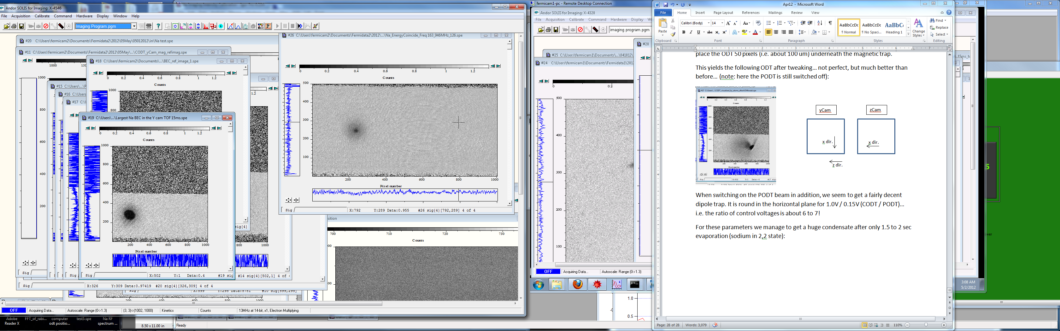 very impressive ☺

🡺 We call the problem solved for now, but we know that a fiber would improve the story (ok, it would suck up some power)

**(b) Investigations on Na yCam imaging**

We find out that there is a very minor offset on the y-images that results from the imaging repumper beam shining in briefly before the actual image is taken.

We actually would like to shine in the repumper from the side (x direction), but it turns out that this would require not so little rebuilding on the Na laser table… Before doing that, we check out the details using the atoms:

1. Having a gap of only 2 usec between the repumper and the imaging light (both aling y-direction), reduces the offset to zero.
2. We don’t see considerable momentum diffusion form the few photons per atom scattered from the repumping beam… anything between 10 and 50 usec duration seems to be fine. [For the case of a condensate, we only need to make sure the repumper fully penetrates the condensate… otherwise, only part of the cloud is imaged.]
3. For imaging light pulses up to 50 us the momemtum diffusion due to photon recoil is small. Only for very long imaging pulses ( > 200us) we see clear momentum diffusion.

[ADD QUANTITATIVE DATA from corresponding IGOR file HERE…]

[However: When imaging molecules, the momentum diffusion aspect is more severe, since really the 100kHz binding energy are imparted on the atoms…]

Tomorrow we check, how 40K likes the newly aligned dipole trap and proceed with the characterizations (trap frequency, N count, TOF measurement, etc)

We also carefully study the effect on atom number and temperature due to different imaging light intensity and duration.

For the Na|1,1> imaging we noticed that as long as there is a >=2us gap between the repumper beam and camera trigger (camera vertical shift speed is [1.0165]us) camera will not see the repumper light.

So we decided to still repump from the y direction 2us before the camera gets the trigger and we varied the repumper pulse duration and see how the atom number and temperature change.







We also did the same thing with the F=2 beam







10us F=2 imaging pulse will do with stronger intensity



With BEC



*Conclusion:*

**For F=1 imaging,** 30us F=1 light for repumping with a total power of 360uW after the fiber following by (2us wait time in between for the camera to clean up) 10us F=2 light with a total power of 900uW after the fiber in the ycam is a good imaging sequence.

05-02-2012

**Check molecules:**

High-field imaging of K in -9/2 (129.5G): 254.5MHz

**Trying to improve high-field imaging:**

We try to improve on the high-field cloud shape of molecules – the butterfly black and white shape of molecules makes it practically impossible to rely on time of flight images.

We check that the black and white problem is not related to the fact that we are observing molecules. To this end, we transfer about 50 percent atoms from -3/2 to -5/2 and then put the remaining -3/2 atoms into the -1/2 state. In fact, taking an high-field image of the -5/2 atoms shows us the same butterfly shape, as when imaging molecules. So, this confirms that this problem actually originates from off-resonant imaging of the -1/2 atom with the -5/2 light.

[Note: When we have ALL K atoms in the -5/2 state the cloud looks perfectly round.]

[Note: The fact that we see the butterfly also for -5/2 atoms excludes the possibility that the molecule cloud has a weird shape due to a weird shaped overlap region between Na and K.]

The only way, that I see, so solve this problem is to remove the -1/2 atoms either by putting them spatially into a different place (Stern-Gerlach like) or by actually blowing them away.

05-03-12



Each Pixel in the Y camera is **2.48um** not 1.92um

At the Onset of BEC we measured the cloud Temperature:



Fit Last five points



It does go through zero.

Then, we have Na T= Tc = ½*M_Na*(5.89*2.48-6)^2/Kb = 295nK

From the Trapping Frequency:

fx = 85Hz, fy=85Hz, fz=148Hz

We have Tc = 0.94*hbar*omegabar*(N) )^(1/3) /Kb =0.94*hbar*(2*pi*103)*(25000)^(1/3) = 293nK

**05-04-2012**

**Summary of trapping frequency measurements:**

**(a)** Measurements for 40K in a dipole trap at 0.15/1.0V:

**(i)** Dipole release measurement (**strong** spectral components **in bold face**):

*yCam*, real space x-direction: **106.7 ± 2.4** and 188.3 ± 4.3

*yCam*, real space z-direction: 107.7 ± 7.3 and **187.5 ± 1.7**

*zCam*, real space x-direction: **110 ± 2.6** and **187.7 ± 3.9**

*zCam*, real space y-direction: N/A (no decernible signal)

**(ii)** B field kick along y (**strong** spectral components **in bold face**):

*yCam*, real space x-direction: **126.9 ± 1.9** and 187.3 ± 6.0

*yCam*, real space z-direction: N/A and **187.9 ± 1.7**

*zCam*, real space x-direction: N/A (no decernible signal)

*zCam*, real space y-direction: 130.7 ± 6.1 and 184.8 ± 23.5

**(b)** Measurements for Na in a dipole trap at 0.15/1.0V:

**(i)** Dipole release measurement (**strong** spectral components **in bold face**):

*yCam*, real space x-direction: **86 ± 2** and 160 ± 12.5

*yCam*, real space z-direction: 91 ± 5 and **148 ± 2**

*zCam*, real space x-direction: **85 ± 3**  and 151 ± 4

*zCam*, real space y-direction: **85 ± 3**  and 149 ± 4

So, in summary we get:

**40K : ωx = 2π 108 ± 3** and **ωy = 2π 127 ± 3** and **ωz = 2π 187 ± 2**

**23Na : ωx = 2π 85 ± 3** and ***ωy = 2π 101 ± 5*** and **ωz = 2π 148 ± 2**

The theoretical scaling for between the trapping frequencies is ωK = 1.214 x ωNa.

Our data yields a scaling factor of about 1.26 for the x- and z-frequencies, being compatible with the theoretical value within the error bars. ωy for Na is obtained using the experimental scaling factor, because the y-direction was not significantly excited by the dipole release technique.

**05-07-2012**

**Changing B-Field to 126.268 G**

(a) Figuring out the transitions:

Atomic transition from -3/2 to -5/2: 34.255 MHz 🡺 126.268G.

Molecular transition: 34.485 to 34.495 MHz. The molecule binding energy is **235kHz.**

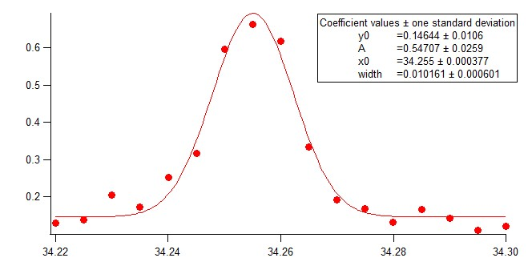

The below spectrum is taken after dissociation, i.e. we use a pulse from -5/2 to -7/2 on the atomic transition at about 32.540 MHz.

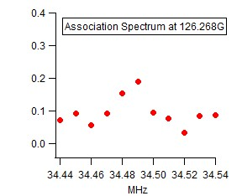

(b) Without Na dropping, i.e. in the presence of all other atoms we record a lifetime curve:

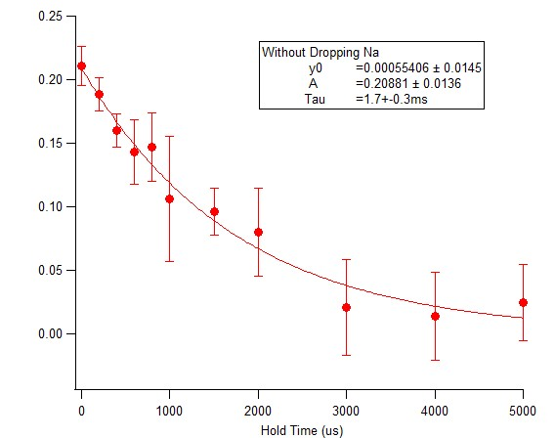

Data quality looks good… note the zero background.

(c) With Na dropping we see a similar lifetime, however, note the huge background:

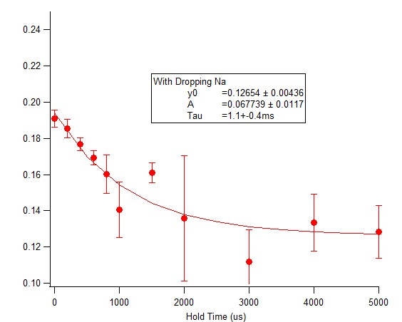

When checking later this large background was also found for data without dropping. So, the difference in the background is not directly connected to dropping or not dropping. It rather seems that the choice of the background box during evaluation has a significant influence here…

However, we feel at this field we do not observe the decay of molecules into -5/2 atoms… so the weird dissociation process does not seem to happen. To kind of prove this we first try to drive a transition on the atomic transition from -5/2 to -7/2 after the creation of molecules. We see a pretty constant signal, but on a large (about 10 per cent transfer ratio) background.

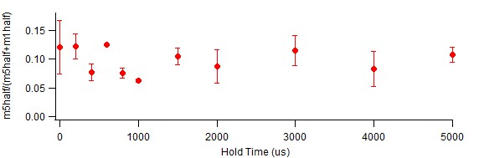

**Problem(s):** Imaging quality. A big problem are for sure fringes and an inhomogeneous imaging beam. However, on top of that we observe very different light levels on the images with and without atoms… This variation of light levels (in kinetics mode!) “visualizes” the imperfections of the imaging beam in addition.

**05-09-12**

Top imaging micrometer reading is 8.69 for 1ms TOF

**Lifetime measurement at different field:**

Previous Keithley value = 4.2845 V, FB PID SetPoint = 4.4 V

**1st try:**

Let’s go to B =132G in order to avoid the m3half s-wave resonance.

This would be Keithley value = 4.37 V

NEW FB PID SetPoint = 4.48 V, Keithley = 4.3678V, B field about 131.96G

Okay. Let’s get the m1half -> m3half right. From the B-R, the frequency should be about 37.389 MHz

**2nd try:**

We change the field again, now to Keithley value 4.3788V (FB PID set: 4.49V), corresponding to a binding energy of about 40kHz and a field of about 132.2G (exactly this value has been used at the end of February).

Transition frequency

-1/2 to -3/2 : 37.43 to 37.53MHz within 1ms

-3/2 to -5/2 (at): ~35.64MHz

Imaging Tandem frequency for

-1/2: 203 MHz (6.399V)

-3/2: 220 MHz (6.862V)

-5/2: 229 MHz

-7/2: 242 MHz

**05-10-2012**

New field around 132 G:

**(a) First we take an atomic spectrum (first one with the nice imaging!):**

(-3dBm, 1ms pulse, using Agilent2 switch)

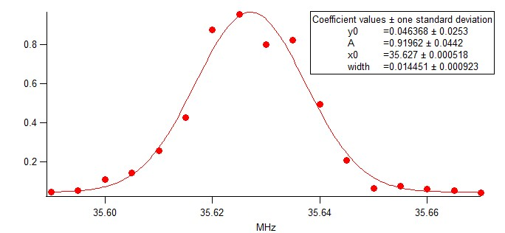

**And after optimizing the field stability, even:**

(-9dBm, 1ms pulse, using Agilent2 switch)

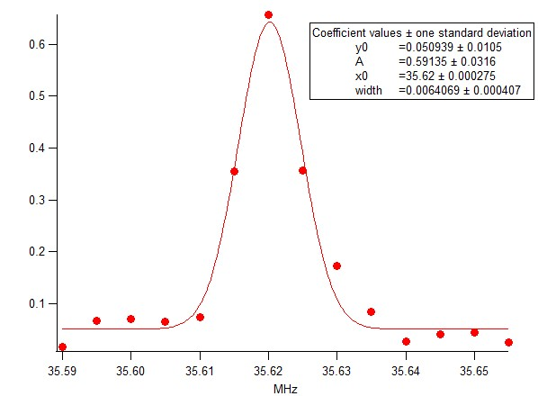

And again:

(-3dBm, 1ms pulse, using Agilent2 switch)

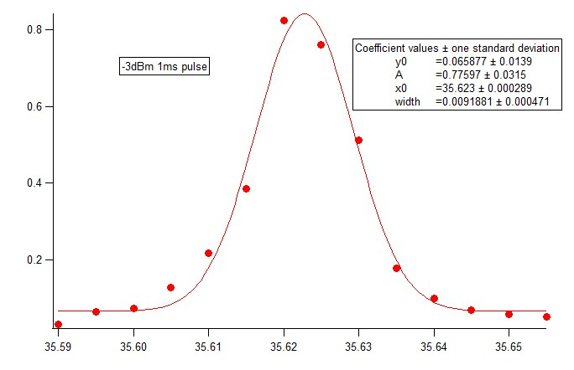

According to Breit-Rabi this **is 132.264 G**.

**(b) Spectrum with molecules:**

(-3dBm, 1ms pulse, using Agilent2 switch)

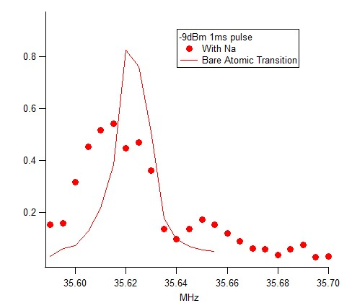

**(c) Dissociation spectrum:**

(+3dBm, 0.5ms pulse)

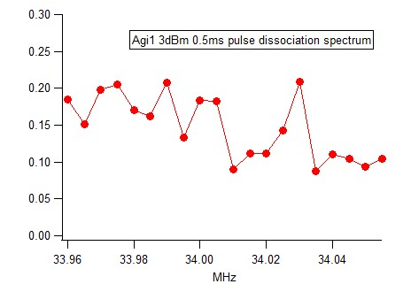

* For the lifetime measurements we decided to do a 0.5ms dissociation sweep

**(d) Lifetime without Na drop:**

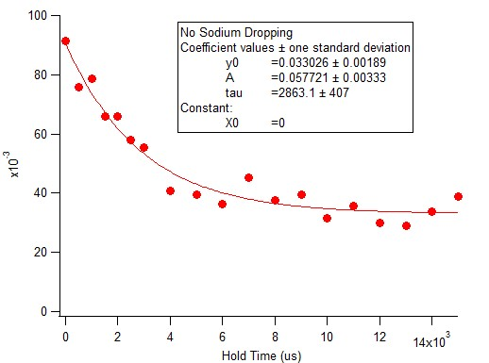

Very nice data… however the lifetime seems quite short. Note however: The dipole trap is probably a bit tighter than in the old data! Here 0.15/1.0V.

**(e) With Na drop:**

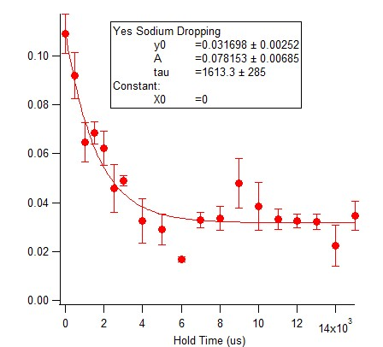

Shit, it’s really worse than without drop… so, we probably also dropped some molecules here ☹

**Trap bottoms Na:** PODT 0.105 CODT 0.2

So, for the drop we use: PODT 0.09 CODT 0.6

**(e) Testing for the maximal conversion:**

Having 2ms hold time after conversion, we vary the dipole trap. PODT fixed at 0.15V, while CODT is varied.

**05-11-12**

**Today we try to spin flip Na from |1,1> to |2,2> at 132G using outer antenna. It seems that the coupling is quite week. It takes about 1s sweep with maximum power to observe 50% transfer. But good side is that pulsing MOT beam for 10us can completely remove to |2,2> at 132G**

|  |  |
| --- | --- |
| **With Spin Flip** | **Without Spin Flip** |
|  |  |

**This is our polaron data starting point**

|  |  |
| --- | --- |
| **40K (0.7-1.3)** | **Na (0-1.3)** |
|  |  |

**NOTE:**

**We noticed that the 2ms molecule creation pulse (0dBm) from agilent2 can induce field fluctuation > 10kHz for 40K -3/2 to -1/2 spin flip at 130G which can easily destroy the following PI pulse not work. One should be extremely careful about the filed stability after applying a RF pulse or sweep.**

**As a result, the temperature data we took today is not conclusive. Because the malfunction of PI pulse, the molecule signal actually was dominated by -3/2 off resonance atomic signal.**

**05-13-12**

**It seems that for the field stability it’s good to have more overhead on the voltage as long as it’s still locked.**







**Zoom in more**













**05/14/2012**

We weren’t able to see the molecular peak yesterday. This may have to do with the recent changes we’ve made to our dipole trap (re-aligning, different trapping frequencies, etc). Our strategy now is to play around with trap bottom while doing the molecular pulse to see if we find molecules.

Today’s bare K40 spectra:



Okay. We’ve set out to find molecules. Not yet seen even if we do more/much less ODT cooling:





It turns out that if the RF power is too high (>-3dBm), molecular conversion is low. The best conversion we found is 2ms, -3dBm pulse



